Would you rather watch
a video on this process?
Watch here!
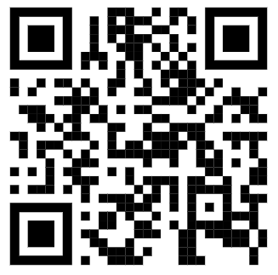

How to Request your Roommate (starting June 1st)
- Go to Edgewood Express, log in using your Edgewood email and password, and click on the Student tab. Scroll to the bottom of the screen and click on Room Selection. From here, you’ll navigate using the left hand Housing links to “Roommate Request.” You can also type the following into your browser: https://rb.gy/yuqz2s
- It will bring you to a screen with a drop-down menu that says “select a session.”
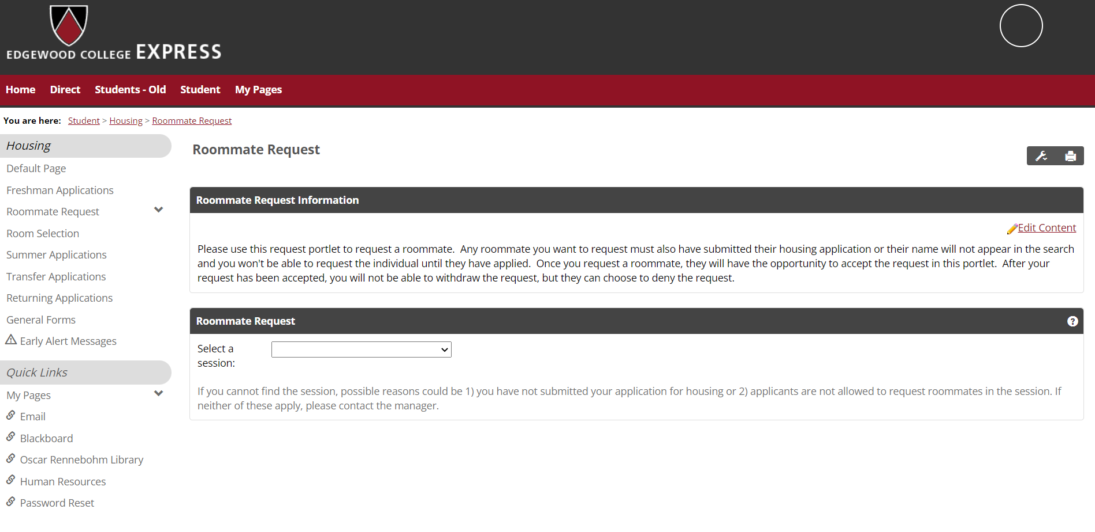
- Select Fall 2022-2023
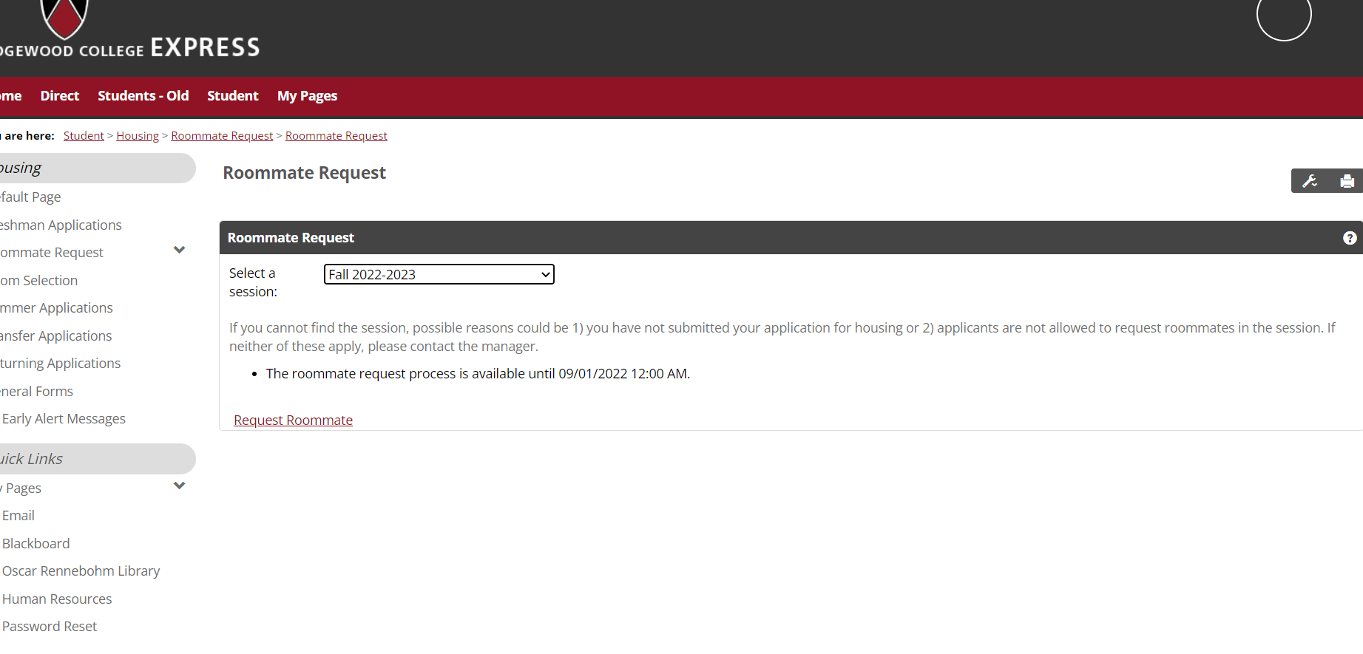
- Click on the Request Roommate button and a text box will appear where you can type in the name of your requested roommate.
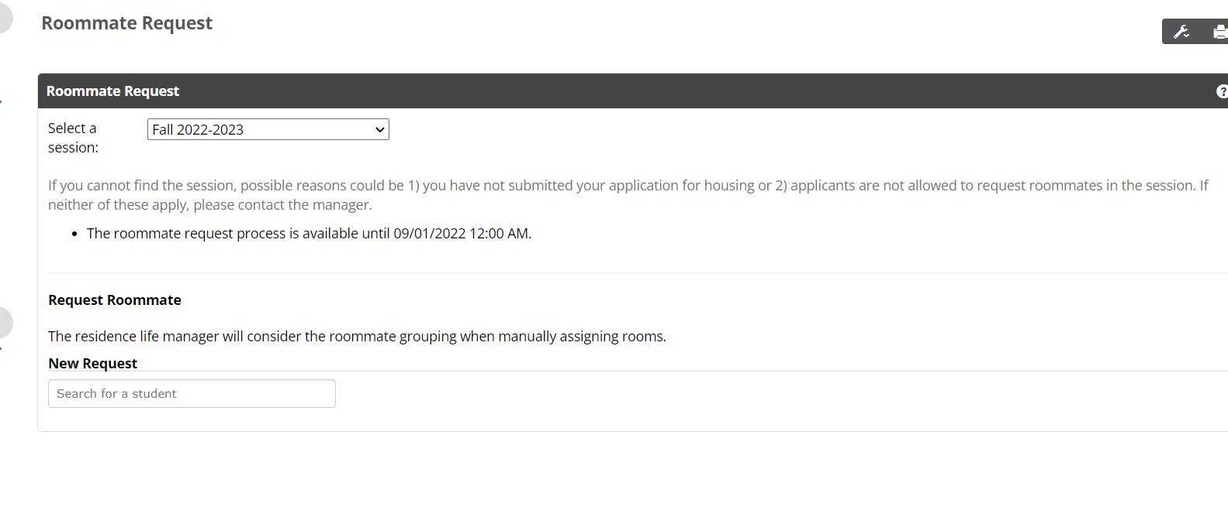

- Type in the name of your requested roommate into the text box and click “Send Request.”
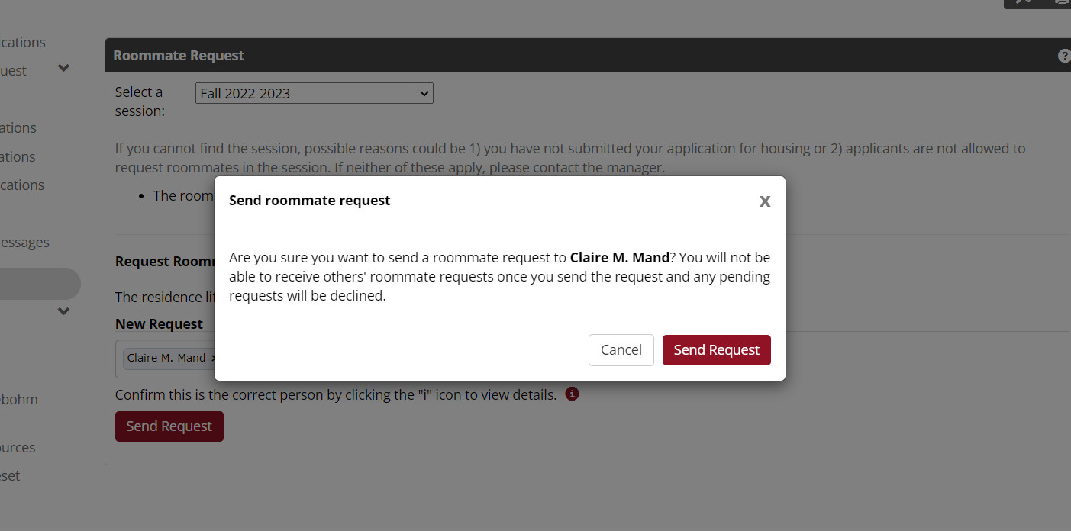

- When completed, your pending request will show up on Edgewood Express page.
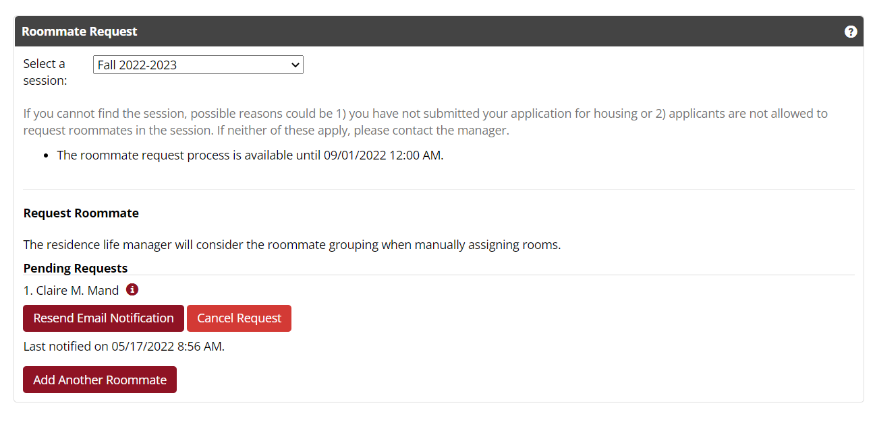
*Tips: You can only accept one request, so make sure you have had a conversation with the roommate you most want to room with. *Only the person who sends a request can cancel the request. *If the student you are looking for does not come up when you search, they likely already have an accepted request or have requested a different roommate. So, have conversations with them ahead of time.

Once you’ve requested a roommate, that person will need to go to this same portlet to accept your request. When accepted, your work is complete! You’ve now requested a roommate and we’ll do our best to place you together!
Email residencelife@edgewood.edu with questions.

